Azure Monitoring Hackathon HammerDB QuickStart

From the Visual Studio Server, download the latest version of HammerDB

Download and Install HammerDB tool on the Visual Studio VM

[www.hammerdb.](http://www.hammerdb.)[com](http://www.hammerdb.com/)

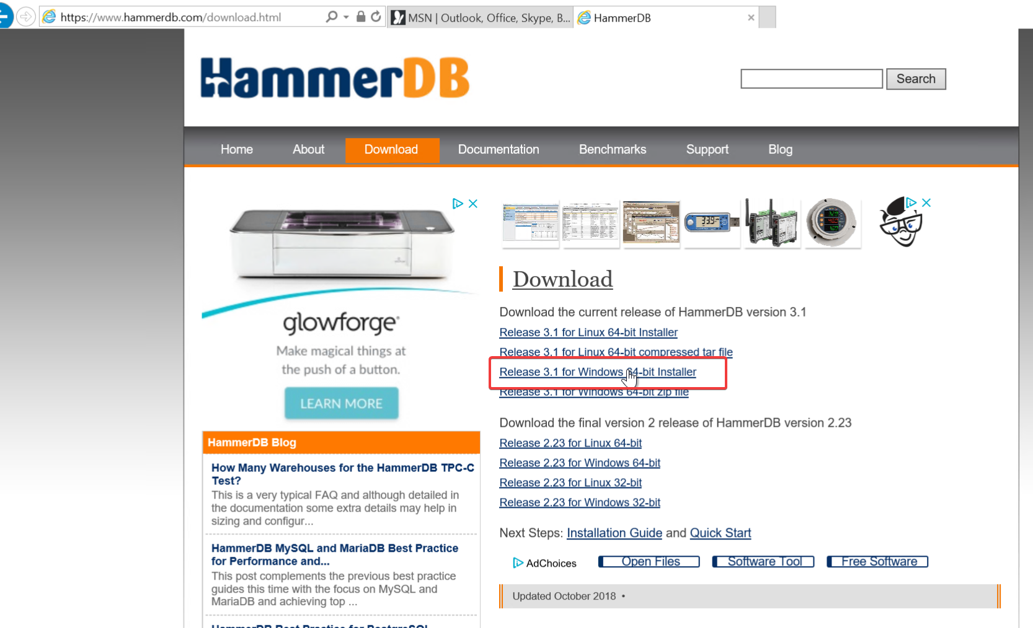

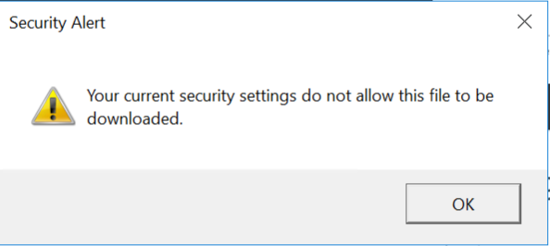

If you get this Security Warning, go to Internet Options.

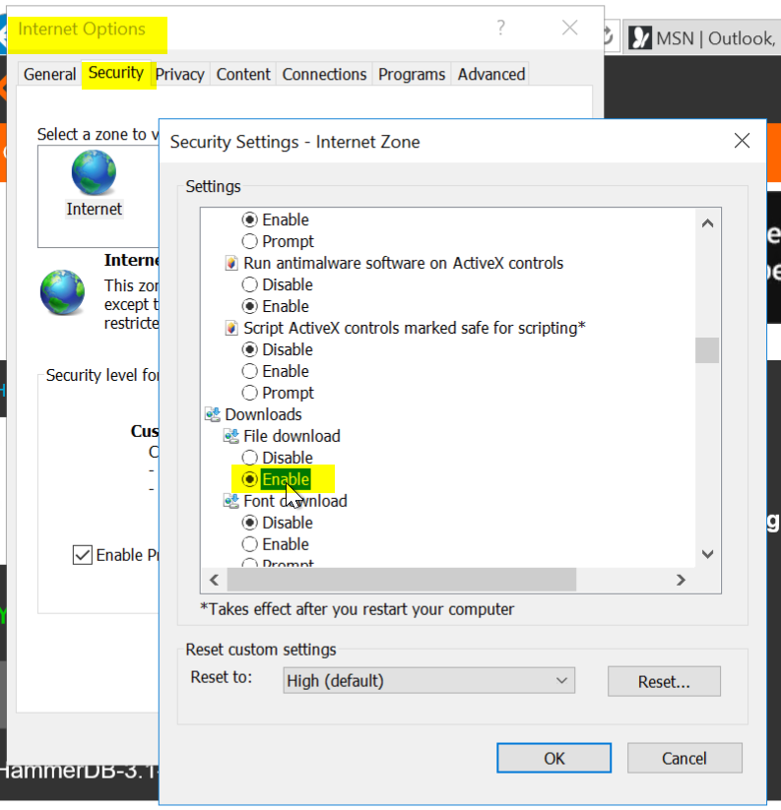

Security \ Security Settings \ Downloads \ File download \ Enable

Click OK

Try again



Click Actions and accept the warnings

Tip: If you end up closing HammerDB you have to go to C:\Program Files\HammerDB-3.1 and run the batch file

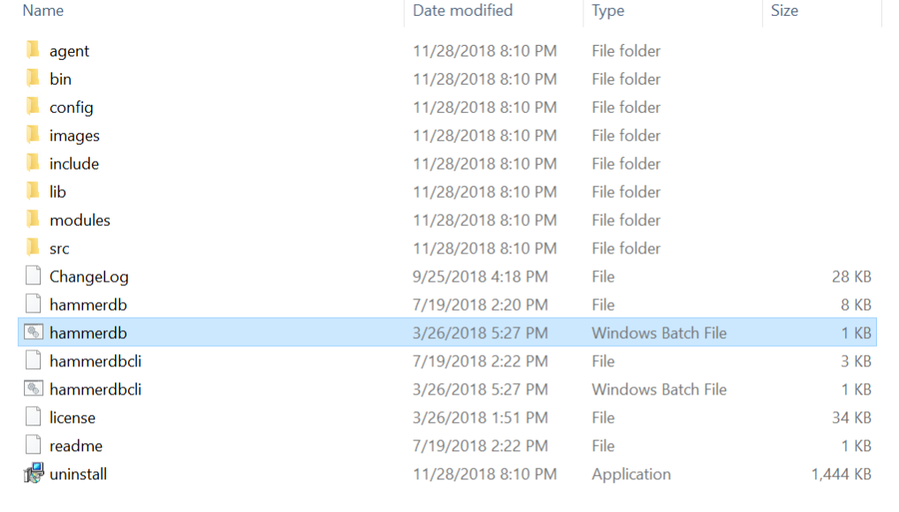

* Use HammerDB to create transaction load

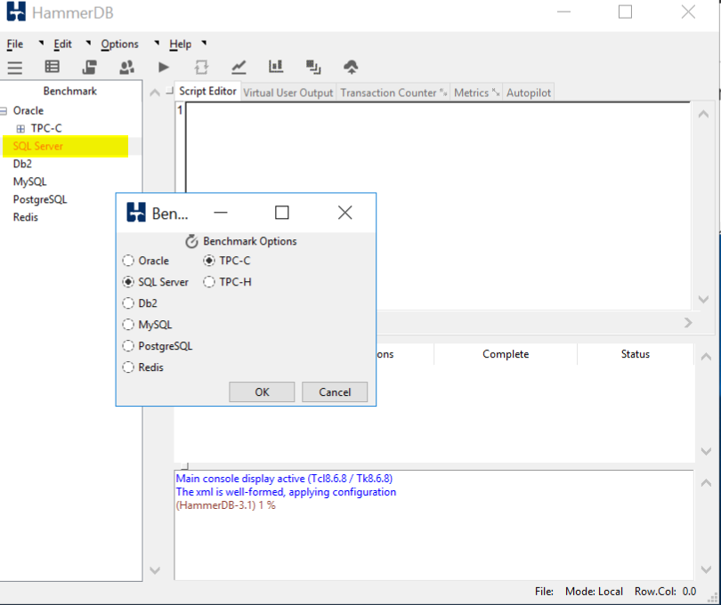

Double click on SQL Server and click OK, and OK on the confirm popup

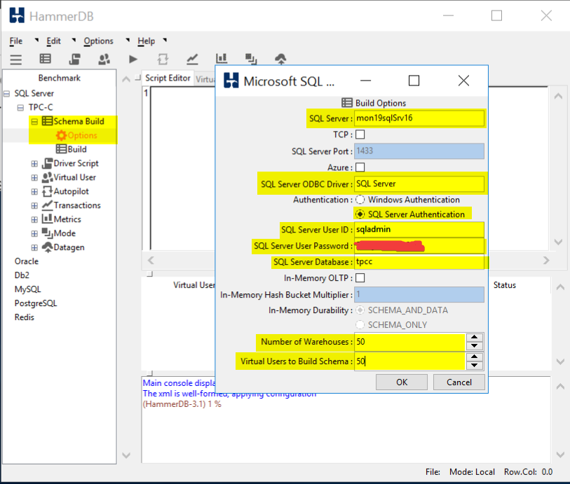

Drill into SQL Server \ TPC-C \ Schema Build and double click on Options

Modify the Build Options for the following:

SQL Server: Name of your SQL Server

SQL Server ODBC Driver: SQL Server

Authentication: SQL Server Authentication

SQL Server User ID: sqladmin

SQL Server User Password: <password you stored in the Key Vault>

SQL Server Database: tpcc

Number of Warehouses: 50

Virtual Users to Build Schema: 50

Note: Setting the last two at 50 should generate enough load to trip a threshold and run long enough for you to graph

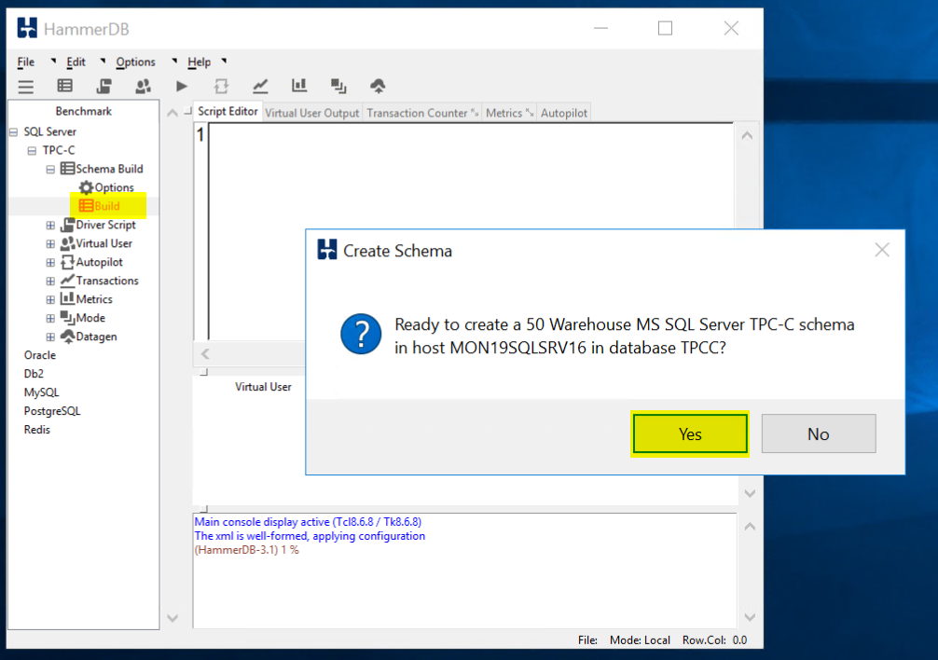

Double click on Build and Click Yes to kick of a load test.

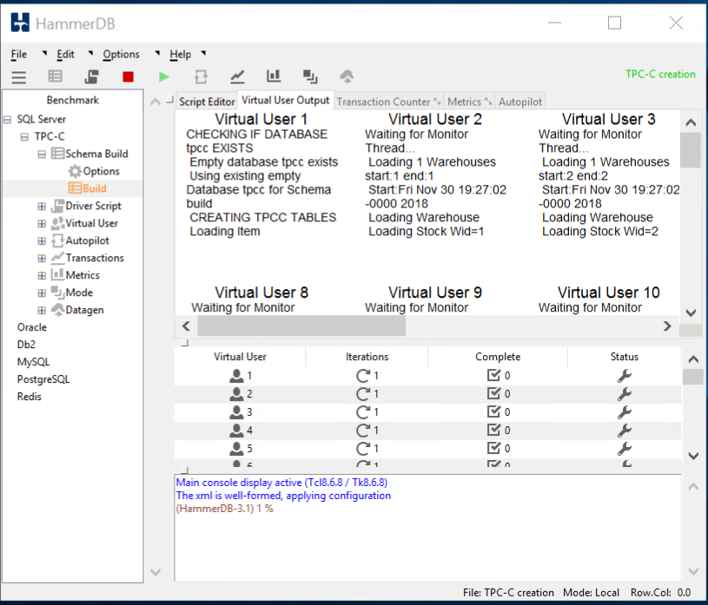

When the test is running it should like this.

TIP: If you would like to run a second test you **must** first delete the database you created and recreate it. HammerDB will not run a test against a database that has data in it. When you run a test is fills the database with a bunch of sample data.